Ardmore Baptist Preschool Calendar
2026-2027
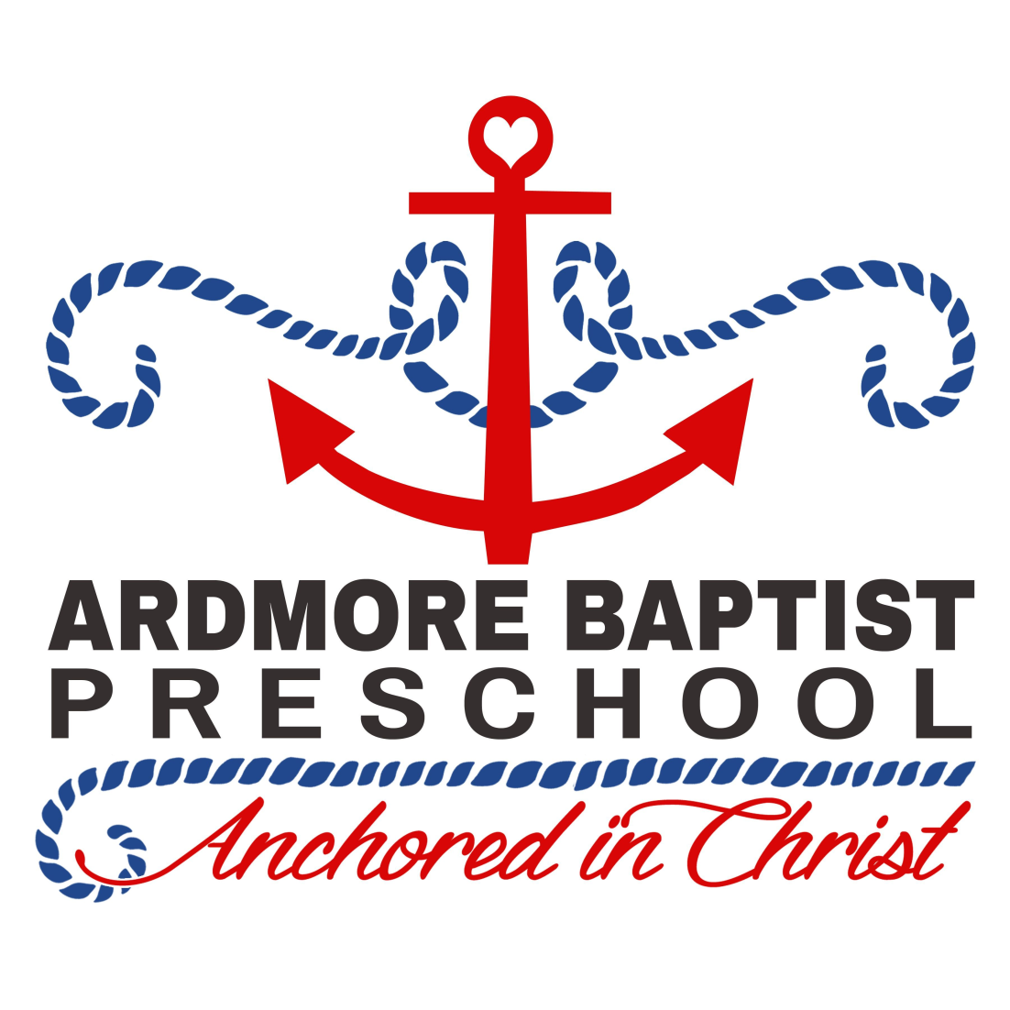
August 17th-21st- Teacher Workdays
August 20th- Parent’s Night
August 21st- Open House (Daytime)
August 24th- First Day of School
September 7th- No School Labor Day
October 12th- No School Teacher Workday
November 3rd- No School Teacher Workday
November 11th- No School Veteran’s Day
November 25th- 27th- No School Thanksgiving Break
December 21st- January 4th- No School Christmas Break
January 18th- No School MLK Day
February 15th- No School Teacher Workday
March 10th- No School Teacher Workday
March 26th- April 2nd- No School Spring Break
May 14th- Last Day of Preschool
May 17th and 18th- Teacher Workdays

*Special Days are subject to change.
October 30th- Fall Festival (2s, 3s, Pre-K)
December 18th- Christmas Program (2s, 3s and Pre-K)
January 22nd- Pancakes and Pajamas
February 7th- Registration opens for 27-28 School year (Feb 21st for new families)
February 9th- Winter Parent Engagement Night
March 16th- Donuts with Dad (3s and Pre-K)
April 30th- Art in the Park(ing) Lot (Evening event, whole school)
May 7th- Mom’s Day event (3s and Pre-K)
May 10th- Pre-K Picnic (only pre-k classes)

*The first two weather days missed will not be made up. If we miss 3-5 days, we will make up those three days beginning May 17-19. Any missed days after that will be at the discretion of the committee using some extended days.
* Calendar subject to change if W-S/FC Schools changes their calendar.

